Module:
Big Data Analytical Methods
Assessment Title:
CA2 – Big Data Analytics Using Hadoop, Spark and MongoDB
Submitted By:
Moshood Folami
Student ID:
Sba25078
Lecturer:
Dr. Muhammad Iqbal
Institution:
CCT College Dublin
Date Submitted:
19 June 2026
Word Count:
Approximately 1077 Words

Table of Contents
- Introduction
1.1 Description of the Datasets
- Objectives of Data Storage (Hadoop) and Analysis
- Data Processing
- Justification of Big Data Methods, Frameworks and Design
- Results and Analysis with Visualisations
- Discussion of Challenges and Solutions
- Conclusion
- References

Big Data Analytics Using Hadoop, Spark and MongoDB
1. Introduction
1.1 Description of the Dataset
This project utilised two datasets to demonstrate Big Data storage, processing, and analytics techniques. The first dataset was a global weather dataset containing meteorological information collected from multiple locations worldwide. Variables included country, location name, temperature, humidity, precipitation, wind speed, air quality indicators, atmospheric pressure, and visibility. The second dataset consisted of FIFA World Cup match data obtained via a football API, including match scores, match status, participating teams, and match outcomes.
The weather dataset can be classified as semi-structured because it contains nested attributes such as air quality measurements. Similarly, the football dataset contains structured and semi-structured information obtained from API responses. Both datasets generate large volumes of data and are suitable for Big Data technologies due to their variety and scalability requirements (World Bank, 2016).

2. Objectives of Data Storage
The primary objective of using Hadoop was to provide scalable and fault-tolerant storage for large datasets. Hadoop Distributed File System (HDFS) stores data across multiple nodes and maintains availability through replication mechanisms (Apache Hadoop, 2024).
The analytical objectives for the weather dataset were to identify temperature patterns, humidity levels, precipitation trends, and air-quality conditions across countries. For the football dataset, the objective was to monitor FIFA World Cup matches and perform streaming-style analytics that could support real-time sports monitoring and decision-making.
Together, these objectives demonstrate how Big Data technologies can be used to process both environmental and sports data efficiently while supporting large-scale analytical workloads (Apache Spark, 2024).

3. Details of Data Processing
Apache Spark was selected as the primary processing framework because it supports distributed in-memory computation, enabling efficient processing of large datasets (Apache Spark, 2024).
For the weather dataset, data was loaded from HDFS into Spark Data Frames. Data cleaning procedures included removing missing values, removing duplicate records, renaming columns, validating humidity values between 0 and 100 percent, filtering unrealistic temperature measurements, and removing invalid wind speed values. These steps improved data quality and ensured accurate analytical results.
Following data cleaning, Spark SQL functions were used to perform aggregations, such as average temperature by country, humidity, and rainfall analyses. The processed data was used for visualisation and imported into MongoDB for further querying and storage. The queries that were performed are Find All Records for a Specific Country (Ireland), Average Temperature by Location and Count Number of Records per Country.
The football analytics component applied Spark concepts to analyse FIFA World Cup matches data. Several analytical tasks were implemented. High-scoring match detection identified matches where either team scored three or more goals. Match status tracking monitors games across stages such as Scheduled, In Play, and Finished. Match count analysis grouped matches according to their status, providing tournament-level monitoring. Goal difference analysis calculated score margins between teams, while draw detection identified closely contested matches ending with equal scores.
These tasks demonstrate practical applications of Spark for streaming-oriented analytics and highlight how sports organisations can monitor live events and generate insights from continuously updated data.

4. Justification of Big Data Methods, Frameworks and Design
Hadoop was selected because it provides scalable distributed storage and fault tolerance. HDFS distributes data across multiple servers and maintains data availability through replication, making it suitable for large datasets (Apache Hadoop, 2024).
Apache Spark was chosen because it processes data in memory, resulting in significantly faster execution compared with traditional MapReduce approaches. Spark also supports SQL operations, streaming analytics, machine learning, and large-scale data processing, making it highly suitable for both weather and football analytics (Apache Spark, 2024).
MongoDB was selected as the NoSQL database because it stores information using flexible document structures. Weather data contains nested air-quality measurements, while football API responses often contain semi-structured attributes. MongoDB's schema flexibility enables efficient storage and retrieval of such information (MongoDB, 2024a).
Compared with relational databases, NoSQL systems provide horizontal scalability through sharding and support evolving data structures without requiring extensive schema modifications. These characteristics make MongoDB suitable for large-scale analytical applications (MongoDB, 2024b; AWS, 2024).

5. Results and Analysis with Visualisations
The weather analysis produced several significant findings. Aggregation queries in MongoDB identified locations such as Ar Riyadh and Kuwait as having the highest average temperatures, exceeding 40°C. Country-level analysis also revealed differences in data availability, with Bulgaria, Indonesia, Thailand, Sudan, and Turkey recording the largest numbers of weather observations.
Analysis of Ireland's weather records showed temperatures generally ranging between 12°C and 19°C, relatively high humidity levels, and low air pollution indicators. Weather conditions were frequently described as cloudy or misty, reflecting Ireland's maritime climate.
Visualisations from Spark, including bar charts, were used to present average temperature, humidity, rainfall, and record distribution statistics. These charts improved understanding of trends and enabled comparisons across countries (Open Data Institute, 2022).

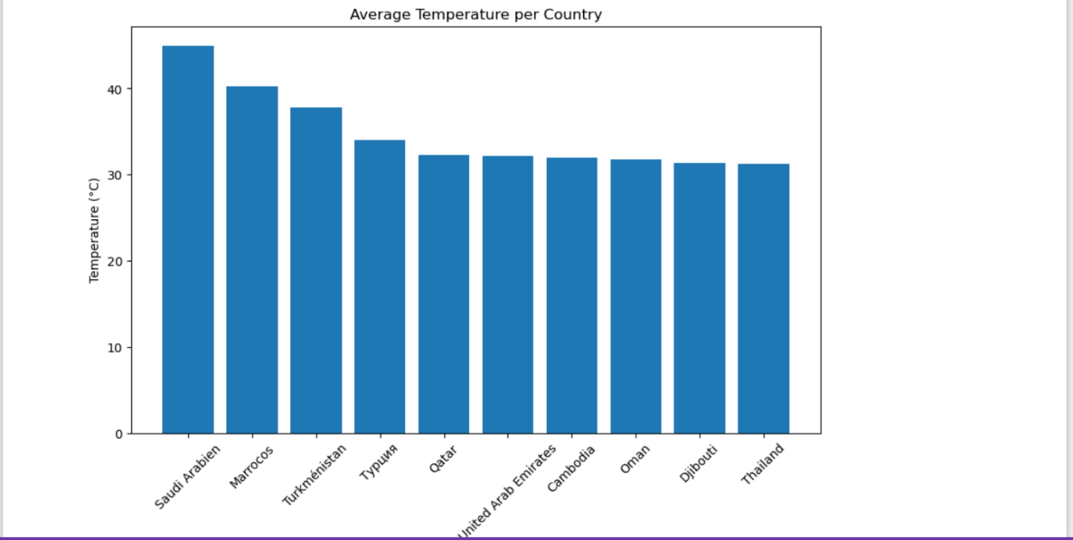

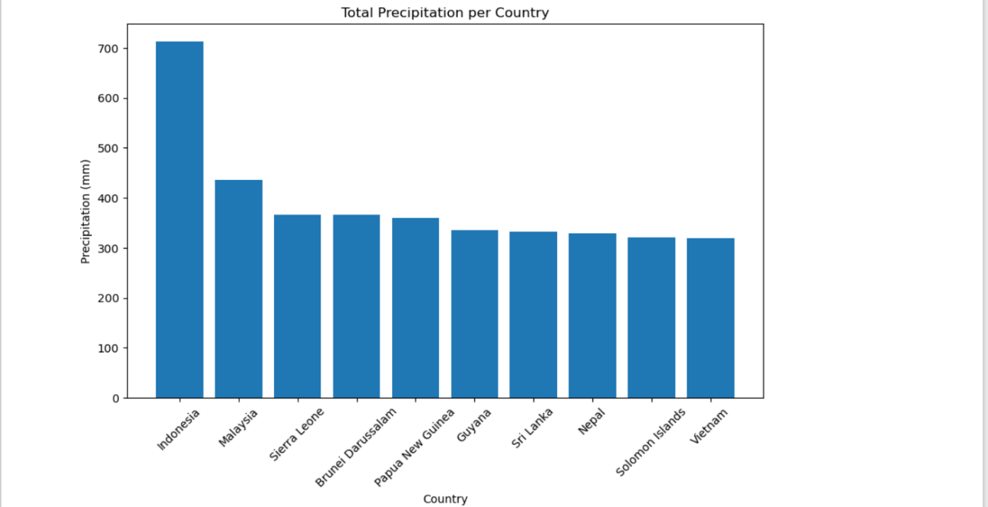

The football analytics component also generated meaningful insights. High-scoring match detection identified games likely to attract fan interest and media attention. Match status tracking provided a mechanism for monitoring tournament progress in real time. Goal difference calculations highlighted dominant team performances and could potentially support predictive analytics. Draw detection identified competitive matches that might require extra time or penalty shootouts.
These results demonstrate how analytical systems can transform raw data into actionable insights for both environmental monitoring and sports management.

6. Discussion of Challenges and Solutions
Several challenges were encountered during the project. The first challenge involved processing large datasets efficiently. Weather observations and football match data can grow rapidly, making traditional processing methods inefficient. Spark addressed this issue through distributed processing and in-memory computation, improving performance and scalability (Apache Spark, 2024).
Secondly, the challenge involved data quality. Missing values, duplicate records, and invalid measurements could reduce analytical accuracy. Data cleaning and validation procedures were therefore applied before analysis.
Another challenge involved handling semi-structured data. Both datasets contained nested fields and varying attributes that are difficult to manage using traditional relational databases. MongoDB's document-oriented architecture provided a flexible solution for storing and querying such information (MongoDB, 2024a).
The football analytics also highlighted a limitation regarding real-time processing. While the analysis demonstrated streaming concepts and real-time monitoring scenarios, it primarily operated on batch Data Frames rather than a true Structured Streaming implementation. Future improvements could incorporate Spark Structured Streaming using continuous data ingestion and processing pipelines.
Security and ethical considerations were also important. MongoDB supports Role-Based Access Control (RBAC), encryption, authentication, and X.509 certificate authentication to secure database resources (MongoDB, 2024c; MongoDB, 2024d). Organisations should apply transparency and responsible data management principles when collecting and analysing data (European Union, 2018).
Conclusion
This project demonstrated the use of Hadoop, Apache Spark, and MongoDB for storing, processing, and analysing large-scale datasets. Hadoop provided scalable storage, Spark enabled efficient distributed analytics, and MongoDB supported flexible storage of semi-structured information. The weather analytics component revealed temperature and environmental trends, while the football analytics component demonstrated streaming-oriented monitoring and sports analytics. These technologies illustrate the value of Big Data frameworks for managing diverse datasets and generating meaningful insights.
References
Apache Hadoop (2024) Hadoop documentation: HDFS architecture. Available at: https://hadoop.apache.org/.
Apache Spark (2024) Apache Spark official documentation. Available at: https://spark.apache.org/.
AWS (2024) What is NoSQL? Introduction to NoSQL databases. Available at: https://aws.amazon.com/nosql/.
European Union (2018) General Data Protection Regulation (GDPR). Available at: https://eur-lex.europa.eu/eli/reg/2016/679/oj.
MongoDB (2024a) MongoDB manual: Document data model. Available at: https://www.mongodb.com/docs/.
MongoDB (2024b) MongoDB scalability and sharding. Available at: https://www.mongodb.com/docs/manual/sharding/.
MongoDB (2024c) Security and authentication in MongoDB. Available at: https://www.mongodb.com/docs/manual/security/.
MongoDB (2024d) Role-Based Access Control (RBAC) in MongoDB. Available at: https://www.mongodb.com/docs/manual/core/authorization/.
Open Data Institute (2022) Data visualisation best practices. Available at: https://theodi.org/.
World Bank (2016) Big data and data classification overview. Available at: https://www.worldbank.org/.

